Contents
Summary 2
Overall Production Stats 3
Third Down Report 4
RedZone Report 4
Early Down Report (1st and 2nd Down) 5
Passing Down Report 5
Fourth Down Report 6
Explosive Plays Report 7
Finishing Drives 8
Hidden Yards 8
Appendix - Charts and Rankings 9

Summary
Top 10 Highlights
- Defense dominates: 23 of 30 top-10 rankings are defensive
- Early down defense is the standout: 8th in success rate, YPA, run stuff, sack%, explosive%
- Finishing drives defense: 4th in avg start pos allowed (OPP 29), 6th in TD rate, 8th in pts/drive
- 4th-Down Offense: 1st in explosive plays, 6th in rush conversion, 9th in overall conversion
Bottom 10 Concerns
- Sack rate is a recurring problem: 60th–64th across early down, passing down, and 3rd down
- 4th down defense: 64th in YPA allowed, 66th in explosive plays allowed — opponents gash Foothill on 4th and short
- 3rd down offense: 58th in YPA, 61st in explosive rate - can't generate big plays on 3rd down
- Redzone offense: 57th in run stuff % - getting stuffed a lot in the red zone rushing

All data scraped from 3c2a/PrestoSports and derived from raw play by play logs

Overall Production Stats
Offense |  | Defense
Passing
44.5 (47th) | % Plays Pass | 52.4 (17th)
1,657 (48th) | Total Yards | 2,391 (44th)
6.18 (47th) | Yards per Attempt | 7.45 (42nd)
16 (40th) | TD | 17 (16th)
55.6% (40th) | Comp Pct | 57.0% (24th)
67 (44th) | 10+ Yd Completions | 90 (39th)
24 (46th) | 20+ Yd Completions | 39 (52nd)
35.1 (53rd) | Success Rate | 38.6 (19th)
Rushing
60.4 (13th) | % Plays Run | 52.4 (38th)
1520 (33rd) | Total Yards | 1237 (17th)
3.73 (42nd) | Yards Per Attempt | 3.5 (13th)
12 (44th) | TD | 10 (7th)
52 (34th) | 10+ Yard Rushes | 41 (11th)
7 (50th) | 20+ Yard Rushes | 13 (34th)
46.7 (18th) | Success Rate | 38.9 (13th)

Third Down Report
Foothill allowed the highest sack rate on third down last season (12.4% of dropbacks), but defense tied for the most turnovers recorded (11).
Offense |  | Defense
148 | Attempts | 149
48 | Conversions | 52
32.4 (49th) | Conversion % | 34.9 (19th)
8.6 (49th) | Avg Yards to Go | 8.9 (9th)
54.1 (31st) | % 3rd & Long (7+) | 59.7 (20th)
14.9 (30th) | % 3rd & Short (<3) | 15.4 (43rd)
4.52 (58th) | Yards per Play | 5.58 (23rd)
11 (54th) | Explosive Plays | 20 (49th)
43 (29.1%, 48th) | % Rush Plays | 54 (36.2%, 43rd)
92 (62.2%, 33rd) | % Pass Plays | 86 (57.7%, 51st)
51.2 (21st) | Rush Conversion % | 37.0 (10th)
28.3 (51st) | Pass Conversion % | 37.2 (34th)
12.4 (62nd) | Sack % | 9.5 (11th)
8 (55th) | Turnovers | 11 (1st)
48 (44th) | Penalty Yards | 35 (37th)

RedZone Report
Foothill defense allowed just 21% of opponents drives to reach the redzone (9th)
Offense | Metric | Defense
38 (29.2%, 34th) | Drives Inside 20 | 28 (21.2%, 9th)
65.8 (54th) | Score % | 71.4 (19th)
52.6 (55th) | TD % | 53.6 (10th)
13.2 (29th) | FG % | 17.9 (55th)
34.2 (54th) | Stop % | 28.6 (19th)
63.3 | % Rush Plays | 54.5
3.35 (21st) | Rush YPC | 3.97 (58th)
34.8 (57th) | Run Stuff % | 27.8 (20th)
11 (41st) | Rush TD | 9 (10th)
33.0% | % Pass Plays | 42.4%
44.4 (43rd) | Comp % | 46.4 (24th)
8 (37th) | Pass TD | 5 (6th)
0 (1st) | Interceptions | 2 (14th)

Early Down Report (1st and 2nd Down)
Foothill defense ranked high in average yards per attempt (3.8), explosive play rate allowed (10%). and overall success rate (8th) on third down last season. Foothill offense passed on just 26% of early downs last season, one of the lowest rates in the state, but allowed a sack on 11% of those dropbacks (3rd-highest rate allowed)
Offense | Metric | Defense
4.85 (50th) | Yards per Play | 4.86 (10th)
47.9 (38th) | Success Rate | 42.5 (8th)
13.2 (39th) | Explosive % | 10.1 (6th)
265 (70.1%, 6th) | % Rush Plays | 197 (55.5%, 45th)
4.88 (35th) | Rush YPA | 3.82 (7th)
21.1 (32nd) | Run Stuff % | 28.9 (8th)
41 (21st) | Explosive Runs | 22 (5th)
100 (26.5%, 62nd) | % Pass Plays | 146 (41.1%, 28th)
6.31 (49th) | Pass YPA | 7.17 (24th)
58.0 (40th) | Comp % | 60.3 (30th)
11.5 (64th) | Sack % | 7.6 (8th)
4 (4th) | Turnovers | 10 (24th)
106 (39th) | Penalty Yards | 135 (11th)

Passing Down Report
On passing downs, Foothill defense struggled with an average of 6.0 yards allowed per play, but generated one of the highest sack rates in the state (11.6%). Foothill offense struggled with just a 9.1% explosive play rate.
Offense | Metric | Defense
4.76 (56th) | Yards per Play | 6.01 (32nd)
28.2 (53rd) | Success Rate | 29.9 (20th)
9.1 (60th) | Explosive % | 14.9 (40th)
79 (32.8%, 38th) | % Rush Plays | 96 (35.8%, 27th)
4.13 (55th) | Rush YPA | 6.05 (51st)
21.5 (35th) | Run Stuff % | 24.0 (22nd)
9 (52nd) | Explosive Runs | 19 (52nd)
144 (59.8%, 38th) | % Pass Plays | 152 (56.7%, 56th)
6.46 (45th) | Pass YPA | 7.52 (37th)
55.6 (28th) | Comp % | 53.3 (23rd)
11.1 (60th) | Sack % | 11.6 (4th)
12 (49th) | Turnovers | 12 (11th)
78 (47th) | Penalty Yards | 40 (47th)

Fourth Down Report
On fourth down last season, the Owl’s offense converted on 57% of their 28 attempts (9th), including 6 explosive plays (1st). They elected to pass on 21 of 28 4th down attempts (75%). On defense, the owls allowed 9.7 yards per play on 22 fourth down attempts (3r-most), with opponents converting on half of such attempts.
Offense | Metric | Defense
28 | Attempts | 22
57.1 (9th) | Conversion % | 50.0 (46th)
7.29 (11th) | Yards per Play | 9.68 (64th)
6 (1st) | Explosive Plays | 6 (66th)
7 (25.0%, 60th) | % Rush Plays | 4 (18.2%)
71.4 (6th) | Rush Conversion % | 25.0 (5th)
21 (75.0%, 5th) | % Pass Plays | 17 (77.3%)
52.4 (16th) | Pass Conversion % | 58.8 (54th)

Explosive Plays Report
Last season, the Owls defense allowed just 41 explosive runs (9th), including only a 10% explosive play rate on early downs (6th). On offense, the Owls sat middle of the pack in most explosive play splits.
Offense | Metric | Defense
76 (42nd) | Total Explosives | 80 (24th)
11.2 (45th) | Explosive Rate % | 11.9 (23rd)
24 (46th) | Explosive Passes | 39 (52nd)
9.0 (43rd) | Explosive Pass Rate % | 12.1 (47th)
52 (33rd) | Explosive Runs | 41 (9th)
13.9 (44th) | Explosive Run Rate % | 12.8 (15th)
50 (34th) | Explosive Early Downs | 36 (9th)
13.2 (39th) | Early Down Exp Rate % | 10.1 (6th)
11 (54th) | Explosive 3rd Downs | 20 (48th)
7.4 (61st) | 3rd Down Exp Rate % | 13.3 (33rd)

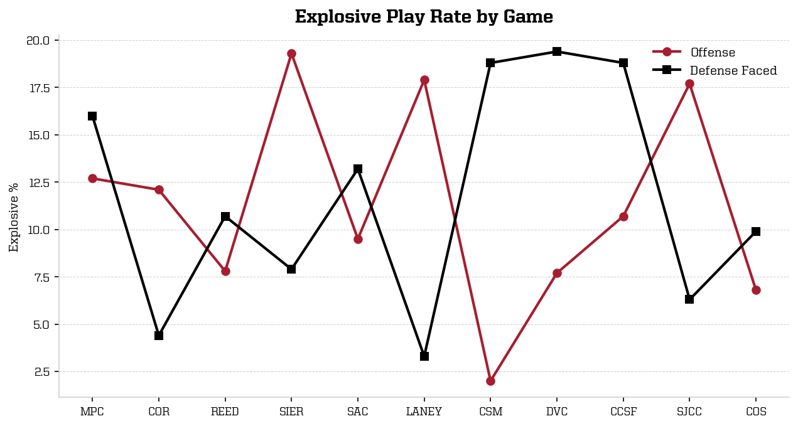

Finishing Drives
The owls defense ranked top 10 in several drive-level categories, including allowing the 6t-lowest touchdown conversion rate (just 21% of drives). Opponents started on their own 29 yard line on average (4th-longest). On offense, the Owls ended roughly 26% of their drives in a score (50th)
Offense |  | Defense
125 | Total Drives | 127
1.69 (48th) | Points per Drive | 1.65 (8th)
26.4 (50th) | Scoring Rate % | 26.8 (10th)
22.4 (48th) | TD Rate % | 21.3 (6th)
4.0 (42nd) | FG Rate % | 5.5 (44th)
36.0 (49th) | Three-and-Out % | 33.9 (20th)
OWN 36 (22nd) | Avg Starting Position | OPP 29 (4th)
5.41 (20th) | Avg Plays per Drive | 5.31 (41st)

Hidden Yards
The Owls defense allowed just 1.2 points per drive when opponents started behind their own 25 (10th).
Offense |  | Defense
0.78 pts (45 drives, 56th) | Backed Up | OFF: OWN 25- / DEF: OPP 75+ | 1.19 pts (75 drives, 10th)
1.84 pts (51 drives, 46th) | Normal | OFF: OWN 26-49 / DEF: OPP 26-49 | 2.13 pts (39 drives, 30th)
2.35 pts (26 drives, 53rd) | Plus | OFF: OPP 26-49 / DEF: OWN 26-49 | 3.1 pts (10 drives, 22nd)
7.0 pts (3 drives, 1st) | Red Zone | OFF: OPP 20- / DEF: OWN 20- | 2.33 pts (3 drives, 7th)
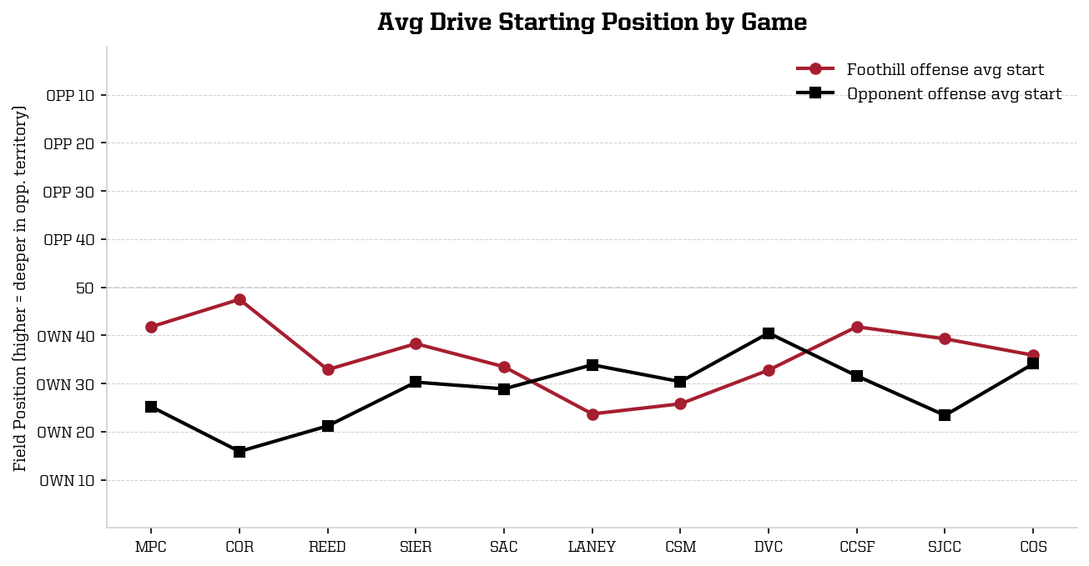

Appendix - Charts and Rankings
